**INTRODUCTION**

This software project is developed to automate the functionalities of a User Friendly Management of a coaching class. The purpose of the software project is to develop a program which provides a user friendly interface for members to classes to manage their student details. This program mainly brings forth the usage of GUI programming in the daily usage over the network. The program when made to work over the network can prove to be an ultimate way of interaction between the user and the system.

A MIS mainly consists of a computerized database, a collection of inter-related tables for a particular subject or purpose, capable to produce different reports relevant to the user. An application program is tied with the database for easy access and interface to the database. Using Application program or front-end, we can store, retrieve and manage all information in proper way.

This software, being simple in design and working, does not require much of training to users, and can be used as a powerful tool for the automating the Coaching classes.

During coding and design of the software Project, Java NetBeans IDE, a powerful front-end tool is used for getting Graphical User Interface (GUI) based integrated platform and coding simplicity. As a back-end a powerful, open source RDBMS, My SQL is used as per requirement of the CBSE curriculum of Informatics Practices Course.

**Objective & Scope of the Project**

T

he objective of the software project is to develop a computerized MIS to automate the functions of a Clothing Store. This software project is also aimed to enhance the current record keeping system, which will help managers to retrieve the up-to-date information at right time in right shape.

The proposed software system is expected to do the following functionality-

* To provide a user friendly, Graphical User Interface (GUI) based integrated and centralized environment for MIS activities.
* The proposed system should maintain all the records and transactions, and should generate the required reports and information when required.
* To provide graphical and user-friendly interface to interact with a centralized database based on client-server architecture.
* To identify the critical operation procedure and possibilities of simplification using modern IT tools and practices.

In its current scope, the software enables user to retrieve and update the information from centralized database designed with MySQL. This software does not require much training time of the users due to limited functionality and simplicity.

During the development of Coaching classesmanagement ‘Aadhar Tutorials’ project, Java NetBeans IDE, a powerful, open source event-driven form-based development environment is used for modular design and future expandability of the system.

Despite of the best effort of the developer, the following limitations and functional boundaries are visible, which limits the scope of this application software.

1. This software can store records and produce reports in pre-designed format in soft copy. There is no facility yet to produce customized reports. Only specified reports are covered.
2. There is no provision to calculate fine or penalty etc. for defaulter members; however it can be developed easily with the help of adding modules.

**System Design & Development**

## Database Design:

An important aspect of system design is the design of data storage structure. To begin with a logical model of data structure is developed first. A database is a container object which contains tables, queries, reports and data validation policies enforcement rules or constraints etc. A logical data often represented as a records are kept in different tables after reducing anomalies and redundancies. The goodness of data base design lies in the table structure and its relationship.

This software project maintains a database named **Aadhar** which contains the following tables.

### Table Design:

The database Aadhar contains 5 tables. The tables are normalized to minimize the redundancies of data and enforcing the validation rules of the organization. Most of the tables are designed to store master records. The tables and their structure are given below.

1. **Login Table**: This table consists faculty’s user id and password which is required to get inside the main frames of project.

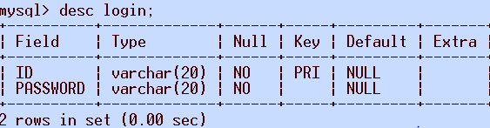

1. **Democ Table**: This table consists data of those students who have applied for registration of demo classes from institute.

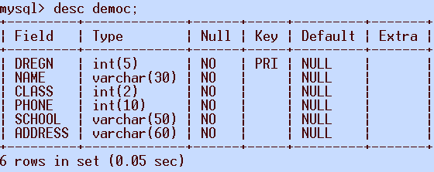

1. **Newst Table:**This table saves the records of students who are registered to the institute and taking classes after paying appropriate fees. It also saves new data of new students.

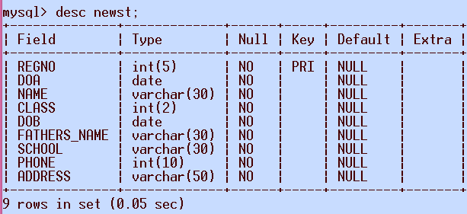

1. **Feech Table:**This table consists the details of fees payment of those students who pay by the means of a cheque.

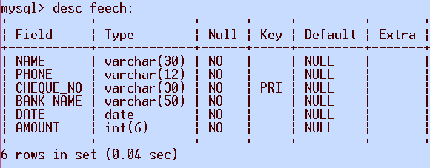

1. **Teachers Table:**This table keeps record of registered teachers of institute.

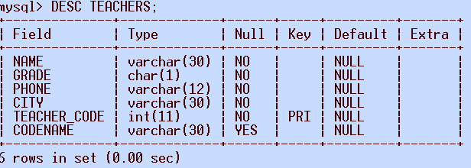

**I/O Forms Design & Event Coding:**

The software project for Coaching Classes Management System ‘Aadhar Tutorials’ contains various forms along with programming codes. Forms (JFrames) and their event coding are given below.

**Frame: MAINPAGE.java**

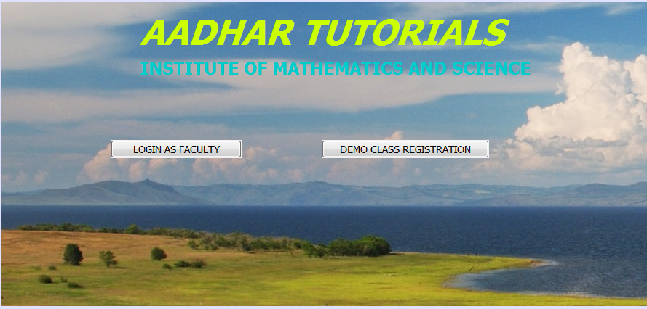

**ON CLICK OF LOGIN AS FACULTY BUTTON**

private void jButton1ActionPerformed(java.awt.event.ActionEvent evt) {

loginpage frm1 = new loginpage();

frm1.setVisible(true);

}

**ON CLICK OF DEMO CLASS REGISTRATION BUTTON**

private void jButton7ActionPerformed(java.awt.event.ActionEvent evt) {

DEMOC frm3 = new DEMOC();

frm3.setVisible(true);

}

**Frame: loginpage.java**

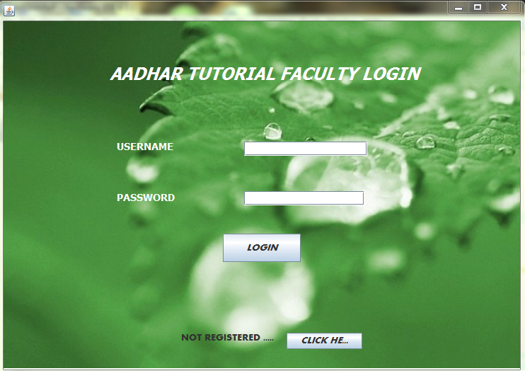

package aadhar;

import java.sql.*;

import javax.swing.JOptionPane;

public class loginpage extends javax.swing.JFrame {

Connection con;

Statement stmt,smt1;

ResultSet rs;

public loginpage() {

initComponents();

jButton2.setVisible(false);

try

{

Class.forName("com.mysql.jdbc.Driver");

con = DriverManager.getConnection("jdbc:mysql://localhost:3306/AADHAR","root","");

}

catch(Exception e)

{

JOptionPane.showMessageDialog(this, e.getMessage());

}

}

**ON CLICK OF LOGIN BUTTON**

private void jButton1ActionPerformed(java.awt.event.ActionEvent evt) {

try{

int flag=0;

String sql="Select * from login;";

smt1=con.createStatement();

rs=smt1.executeQuery(sql);

String log=tf1.getText();

String pass =new String(pf1.getPassword());

while(rs.next())

{

if(log.equals(rs.getString(1)) && pass.equals(rs.getString(2)))

{

flag=1;

break;

}

}

if(flag==1)

{

JOptionPane.showMessageDialog(this, "WELCOME!!!!!");

{ homepage nf=new homepage();

nf.setVisible(true);

{

this.dispose();

}

}

}

else

{

JOptionPane.showMessageDialog(this, "Error", "Please check user name / password",JOptionPane.ERROR_MESSAGE);

tf1.setText("");

pf1.setText("");

jButton2.setVisible(true);

}

}

catch(Exception ex)

{

System.out.print(ex.getMessage());

}

}

**ON CLICK OF NOT REGISTERED CLICK HERE BUTTON**

private void jButton4ActionPerformed(java.awt.event.ActionEvent evt) {

newteacher frmr = new newteacher();

frmr.setVisible(true);

**ON CLICK OF RESET PASSWORD**

private void jButton2ActionPerformed(java.awt.event.ActionEvent evt) {

resetpass sf = new resetpass();

sf.setVisible(true);

}

**Frame: DEMOC.java**

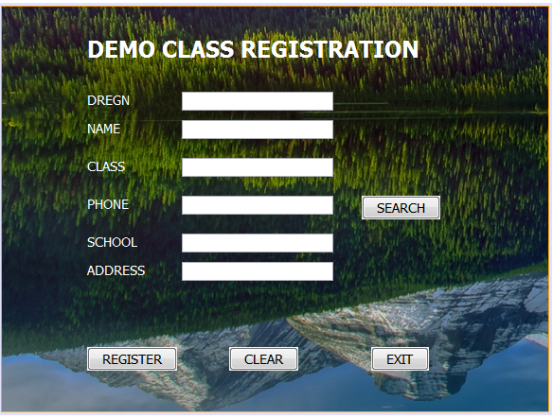

package aadhar;

import java.sql.*;

import javax.swing.JOptionPane;

public class DEMOC extends javax.swing.JFrame {

Connection con = null;

Statement stmt = null;

public DEMOC() {

initComponents();

try {

Class.forName("java.sql.DriverManager");

con = (Connection) DriverManager.getConnection("jdbc:mysql://localhost:3306/AADHAR","root","");

stmt = (Statement) con.createStatement();

} catch(Exception x)

{

JOptionPane.showMessageDialog(this, x.getMessage());

}

}

**ON CLICK OF SEARCH BUTTON**

private void jButton4ActionPerformed(java.awt.event.ActionEvent evt) {

String DREGN, NAME , CLASS, SCHOOL , PHONE , ADDRESS;

DREGN = tx1.getText();

NAME = tx2.getText();

CLASS = tx3.getText();

PHONE = tx4.getText();

SCHOOL = tx5.getText();

ADDRESS = tx6.getText();

try{

Class.forName("java.sql.DriverManager");

Statement stmt = (Statement) con.createStatement();

String Query = "SELECT * FROM DEMOC WHERE PHONE = '"+tx4.getText()+"';";

ResultSet rs = stmt.executeQuery(Query);

if(rs.next())

{

DREGN = rs.getString("DREGN");

NAME = rs.getString("NAME");

CLASS = rs.getString("CLASS");

SCHOOL = rs.getString("SCHOOL");

ADDRESS = rs.getString("ADDRESS");

tx1.setText(DREGN);

tx2.setText(NAME);

tx3.setText(CLASS);

tx5.setText(SCHOOL);

tx6.setText(ADDRESS);

}

else

{

JOptionPane.showMessageDialog(this, "SORRY! NO SUCH NUMBER EXISTS");

}

}catch(Exception e)

{

JOptionPane.showMessageDialog(this,e.getMessage());

}

**ON CLICK OF REGISTER BUTTON**

private void jButton1ActionPerformed(java.awt.event.ActionEvent evt) {

String DREGN,NAME,CLASS,PHONE,SCHOOL,ADDRESS;

DREGN = tx1.getText();

NAME = tx2.getText();

CLASS = tx3.getText();

PHONE = tx4.getText();

SCHOOL = tx5.getText();

ADDRESS = tx6.getText();

try {

Class.forName("java.sql.DriverManager");

con = (Connection) DriverManager.getConnection("jdbc:mysql://localhost:3306/AADHAR","root","");

stmt = (Statement) con.createStatement();

String QUERY = "INSERT INTO DEMOC VALUES('"+tx1.getText()+"','"+tx2.getText()+"','"+tx3.getText()+"','"+tx4.getText()+"','"+tx5.getText()+"','"+tx6.getText()+"');";

stmt.executeUpdate(QUERY);

{

JOptionPane.showMessageDialog(this,"CONGRATULATIONS YOU ARE REGISTERED FOR DEMO CLASSES");

}

} catch (Exception ef)

{

JOptionPane.showMessageDialog(this, ef.getMessage());

}

}

**ON CLICK OF RESET BUTTON**

private void jButton2ActionPerformed(java.awt.event.ActionEvent evt) {

tx1.setText("");

tx2.setText("");

tx3.setText("");

tx4.setText("");

tx5.setText("");

tx6.setText("");

}

**ON CLICK OF EXIT BUTTON**

private void jButton3ActionPerformed(java.awt.event.ActionEvent evt) {

this.dispose();

}

**Frame: homepage.java**

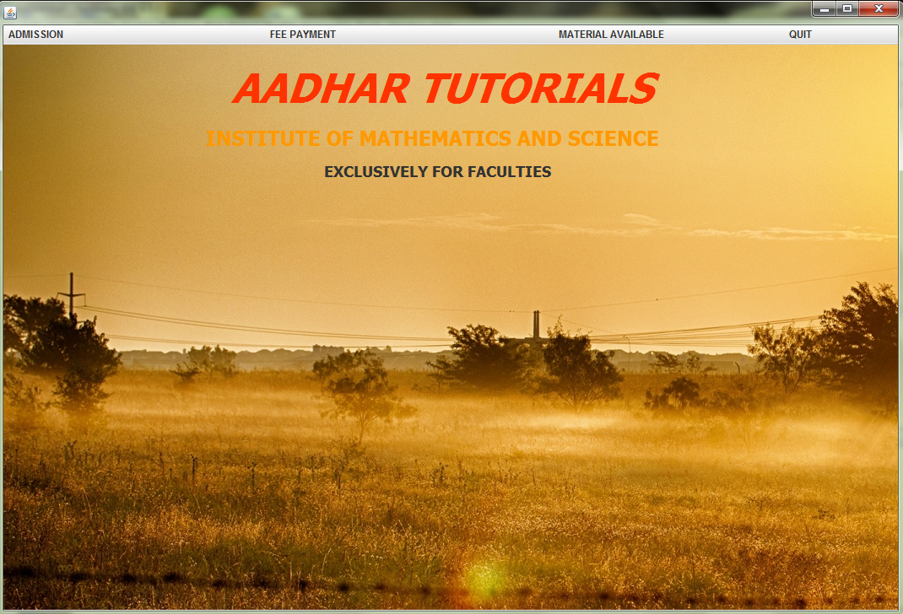

package aadhar;

import java.sql.SQLException;

import java.util.logging.Level;

import java.util.logging.Logger;

import javax.swing.JOptionPane;

public class homepage extends javax.swing.JFrame {

private Object OBJ;

private void jMenuItem1ActionPerformed(java.awt.event.ActionEvent evt) {

try {

newstudent frm10 = new newstudent();

jDesktopPane1.add(frm10);

frm10.setVisible(true);

} catch (SQLException ex) {

Logger.getLogger(homepage.class.getName()).log(Level.SEVERE, null, ex);

}

}

private void jMenuItem2ActionPerformed(java.awt.event.ActionEvent evt) {

updatestudent frm = new updatestudent();

jDesktopPane1.add(frm);

frm.setVisible(true);

}

private void jMenuItem4ActionPerformed(java.awt.event.ActionEvent evt) {

feepmntcash frma = new feepmntcash();

jDesktopPane1.add(frma);

frma.setVisible(true);

}

private void jMenuItem5ActionPerformed(java.awt.event.ActionEvent evt) {

feepmntcheque frmb = new feepmntcheque();

jDesktopPane1.add(frmb);

frmb.setVisible(true);

}

private void jMenu4ActionPerformed(java.awt.event.ActionEvent evt) {

}

private void jMenuItem8ActionPerformed(java.awt.event.ActionEvent evt) {

MATDOWPHY frmK = new MATDOWPHY();

jDesktopPane1.add(frmK);

frmK.setVisible(true);

}

private void jMenuItem9ActionPerformed(java.awt.event.ActionEvent evt) {

MATDOWCHEM frmN = new MATDOWCHEM();

jDesktopPane1.add(frmN);

frmN.setVisible(true);

}

private void jMenuItem10ActionPerformed(java.awt.event.ActionEvent evt) {

MATDOWMATH frmM = new MATDOWMATH();

jDesktopPane1.add(frmM);

frmM.setVisible(true);

}

private void jMenuItem11ActionPerformed(java.awt.event.ActionEvent evt) {

JOptionPane.showConfirmDialog(this, "DO YOU WANT TO EXIT???");

{

JOptionPane.showMessageDialog(this, "THANK YOU !!!");

System.exit(0);

}

}

private void jMenuItem3ActionPerformed(java.awt.event.ActionEvent evt) {

DETAILVIEW frmR = new DETAILVIEW();

frmR.setVisible(true);

**Frame: newstudent.java**

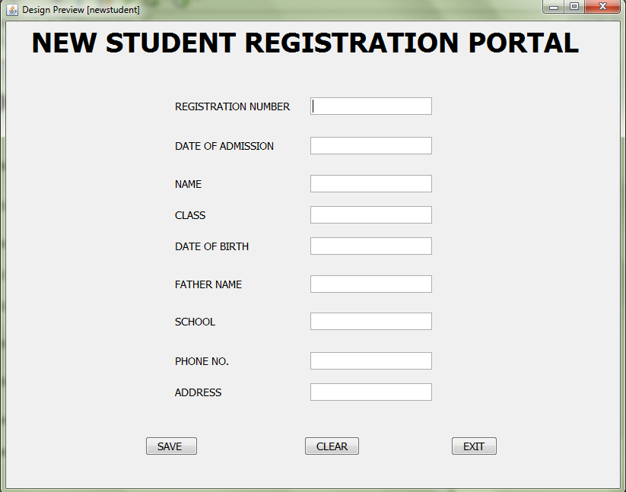

package aadhar;

import java.sql.*;

import javax.swing.JOptionPane;

public class newstudent extends javax.swing.JInternalFrame {

Connection con = null;

Statement stmt = null;

public newstudent() throws SQLException {

initComponents();

t6.setText("Mr.");

try {

Class.forName("java.sql.DriverManager");

con = (Connection) DriverManager.getConnection("jdbc:mysql://localhost:3306/AADHAR","root","");

stmt = (Statement) con.createStatement();

} catch(Exception x)

{

JOptionPane.showMessageDialog(this, x.getMessage());

}

}

**ON CLICK OF SAVE BUTTON**

private void jButton1ActionPerformed(java.awt.event.ActionEvent evt) {

String QUERY = "INSERT INTO NEWST VALUES('"+t1.getText()+"','"+t2.getText()+"','"+t3.getText()+"','"+t4.getText()+"','"+t5.getText()+"','"+t6.getText()+"','"+t7.getText()+"','"+t8.getText()+"','"+t9.getText()+"');";

String A,B,C,D,E,F,G,H,I;

A = t1.getText();

B = t2.getText();

C = t3.getText();

D = t4.getText();

E = t5.getText();

F = t6.getText();

G = t7.getText();

H = t8.getText();

I = t9.getText();

try {

Class.forName("java.sql.DriverManager");

con = (Connection) DriverManager.getConnection("jdbc:mysql://localhost:3306/AADHAR","root","");

stmt = (Statement) con.createStatement();

stmt.executeUpdate(QUERY);

{

JOptionPane.showMessageDialog(this,"STUDENT DETAILS ADDED");

}

} catch (Exception ef)

{

JOptionPane.showMessageDialog(this, ef.getMessage());

}

}

**ON CLICK OF EXIT BUTTON**

private void jButton3ActionPerformed(java.awt.event.ActionEvent evt) {

this.dispose();

**ON CLICK OF RESET BUTTON**

t3.setText("");

t4.setText("");

t6.setText("");

t7.setText("");

t8.setText("");

t9.setText("");

t1.setText("");

t2.setText("");

t5.setText("");

**Frame: updatestudent.java**

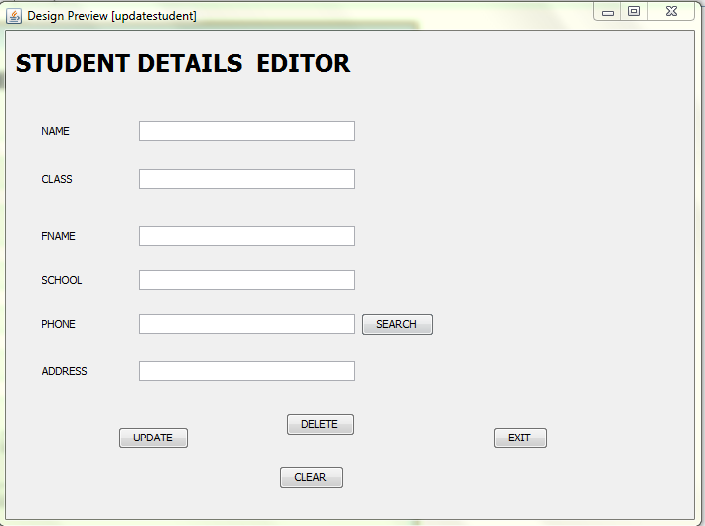

package aadhar;

import java.sql.*;

import javax.swing.JOptionPane;

public class updatestudent extends javax.swing.JInternalFrame {

Connection con = null;

Statement stmt = null;

public updatestudent() {

initComponents();

try {

Class.forName("java.sql.DriverManager");

con = (Connection) DriverManager.getConnection("jdbc:mysql://localhost:3306/AADHAR","root","");

stmt = (Statement) con.createStatement();

} catch(Exception x)

{

JOptionPane.showMessageDialog(this, x.getMessage());

}

**ON CLICK OF SEARCH BUTTON**

private void jButton1ActionPerformed(java.awt.event.ActionEvent evt) {

String NAME , CLASS , FATHERS_NAME , SCHOOL , PHONE , ADDRESS;

NAME = tf1.getText();

CLASS = tf2.getText();

FATHERS_NAME = tf3.getText();

SCHOOL = tf4.getText();

PHONE = tf5.getText();

ADDRESS = tf6.getText();

try{

Class.forName("java.sql.DriverManager");

Statement stmt = (Statement) con.createStatement();

String Query = "SELECT * FROM NEWST WHERE PHONE = '"+tf5.getText()+"';";

ResultSet rs = stmt.executeQuery(Query);

if(rs.next())

{

NAME = rs.getString("NAME");

CLASS = rs.getString("CLASS");

FATHERS_NAME = rs.getString("FATHERS_NAME");

SCHOOL = rs.getString("SCHOOL");

ADDRESS = rs.getString("ADDRESS");

tf1.setText(NAME);

tf2.setText(CLASS);

tf3.setText(FATHERS_NAME);

tf4.setText(SCHOOL);

tf6.setText(ADDRESS);

}

else

{

JOptionPane.showMessageDialog(this, "SORRY! NO SUCH NUMBER EXISTS");

}

}catch(Exception S)

{

JOptionPane.showMessageDialog(this,S.getMessage());

}

}

**ON CLICK OF UPDATE BUTTON**

private void jButton2ActionPerformed(java.awt.event.ActionEvent evt) {

String NAME , CLASS , FATHERS_NAME , SCHOOL , PHONE , ADDRESS;

NAME = tf1.getText();

CLASS = tf2.getText();

FATHERS_NAME = tf3.getText();

SCHOOL = tf4.getText();

PHONE = tf5.getText();

ADDRESS = tf6.getText();

try{

Class.forName("java.sql.DriverManager");

Statement stmt = (Statement) con.createStatement();

String Query = "UPDATE NEWST SET NAME = '"+tf1.getText()+"' ,CLASS = '"+tf2.getText()+"', FATHERS_NAME = '"+tf3.getText()+"', SCHOOL = '"+tf4.getText()+"', ADDRESS = '"+tf6.getText()+"' WHERE PHONE ='"+tf5.getText()+"' ;";

int stmt1 = stmt.executeUpdate(Query);

{

JOptionPane.showMessageDialog(this, "DATA UPDATED SUCCESSFULLY");

}

}catch(Exception e)

{

JOptionPane.showMessageDialog(this,e.getMessage());

}

}

**ON CLICK OF DELETE BUTTON**

private void jButton5ActionPerformed(java.awt.event.ActionEvent evt) {

String NAME , CLASS , FATHERS_NAME , SCHOOL , PHONE , ADDRESS;

NAME = tf1.getText();

CLASS = tf2.getText();

FATHERS_NAME = tf3.getText();

SCHOOL = tf4.getText();

PHONE = tf5.getText();

ADDRESS = tf6.getText();

try{

Class.forName("java.sql.DriverManager");

Statement stmt = (Statement) con.createStatement();

String Query = "DELETE FROM NEWST WHERE PHONE = '"+tf5.getText()+"'";

int stmt1 = stmt.executeUpdate(Query);

{

JOptionPane.showMessageDialog(this, "DATA DELETED SUCCESSFULLY");

}

}catch(Exception W)

{

JOptionPane.showMessageDialog(this,W.getMessage());

}

}

**ON CLICK OF CLEAR BUTTON**

tf1.setText("");

tf2.setText("");

tf3.setText("");

tf4.setText("");

tf5.setText("");

tf6.setText("");

**ON CLICK OF EXIT BUTTON**

private void jButton4ActionPerformed(java.awt.event.ActionEvent evt) {

this.dispose();

**Frame: Detailview.java**

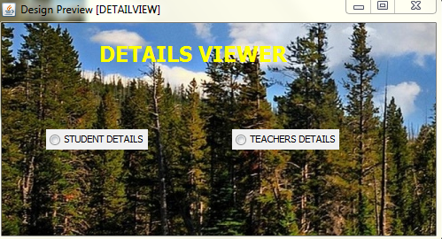

private void jRadioButton2ActionPerformed(java.awt.event.ActionEvent evt) {

TEACHERDET frmb = new TEACHERDET();

frmb.setVisible(true);

}

private void jRadioButton1ActionPerformed(java.awt.event.ActionEvent evt) {

STUDENTDET frma = new STUDENTDET();

frma.setVisible(true);

}

**Frame: feepmntcash.java**

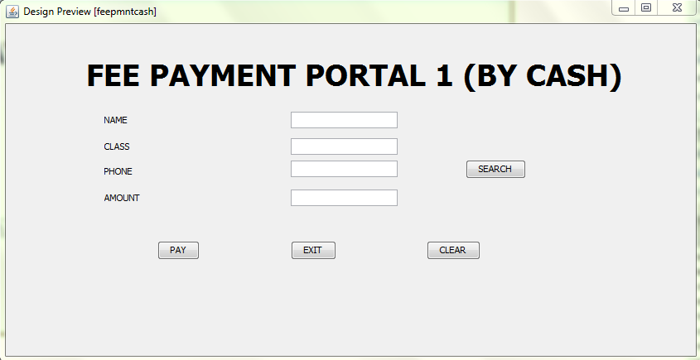

import javax.swing.JOptionPane;

import java.sql.*;

public class feepmntcash extends javax.swing.JInternalFrame {

Connection con = null;

Statement stmt = null;

public feepmntcash() {

initComponents();

try {

Class.forName("java.sql.DriverManager");

con = (Connection) DriverManager.getConnection("jdbc:mysql://localhost:3306/AADHAR","root","");

stmt = (Statement) con.createStatement();

} catch(Exception x)

{

JOptionPane.showMessageDialog(this, x.getMessage());

}

}

**ON CLICK OF SEARCH BUTTON**

private void jButton2ActionPerformed(java.awt.event.ActionEvent evt) {

String Name , Phone;

Name = tx1.getText();

Phone = tx2.getText();

try{

Class.forName("java.sql.DriverManager");

Statement stmt = (Statement) con.createStatement();

String Query = "SELECT * FROM NEWST WHERE PHONE = '"+tx2.getText()+"';";

ResultSet rs = stmt.executeQuery(Query);

if(rs.next())

{

Name = rs.getString("Name");

tx1.setText(Name);

}

else

{

JOptionPane.showMessageDialog(this, "SORRY! NO SUCH NUMBER EXISTS");

}

}catch(Exception e)

{

JOptionPane.showMessageDialog(this,e.getMessage());

}

}

**ON CLICK OF PAY BUTTON**

tx3.setEditable(false);

int A;

String C;

C = TX2.getText();

if(C.equals("6"))

{

tx3.setText("20000");

{

JOptionPane.showConfirmDialog(this, "DO YOU WANT TO PAY AMOUNT OF RS.20000 ?");

{

JOptionPane.showMessageDialog(this, "FEES PAID SUCCESSFULLY!!!!!");

}

}

}

else if(C.equals("7"))

{

tx3.setText("30000");

{

JOptionPane.showConfirmDialog(this, "DO YOU WANT TO PAY AMOUNT OF RS.30000 ?");

{

JOptionPane.showMessageDialog(this, "FEES PAID SUCCESSFULLY!!!!!");

}

}

}

else if(C.equals("8"))

{

tx3.setText("40000");

{

JOptionPane.showConfirmDialog(this, "DO YOU WANT TO PAY AMOUNT OF RS.40000 ?");

{

JOptionPane.showMessageDialog(this, "FEES PAID SUCCESSFULLY!!!!!");

}

}

}

else if(C.equals("9"))

{

tx3.setText("50000");

{

JOptionPane.showConfirmDialog(this, "DO YOU WANT TO PAY AMOUNT OF RS.50000 ?");

{

JOptionPane.showMessageDialog(this, "FEES PAID SUCCESSFULLY!!!!!");

}

}

}

else if(C.equals("10"))

{

tx3.setText("60000");

{

JOptionPane.showConfirmDialog(this, "DO YOU WANT TO PAY AMOUNT OF RS.60000 ?");

{

JOptionPane.showMessageDialog(this, "FEES PAID SUCCESSFULLY!!!!!");

}

}

}

else if(C.equals("11"))

{

tx3.setText("70000");

{

JOptionPane.showConfirmDialog(this, "DO YOU WANT TO PAY AMOUNT OF RS.70000 ?");

{

JOptionPane.showMessageDialog(this,"FEES PAID SUCCESSFULLY!!!!!");

}

}

}

else if(C.equals("12"))

{

tx3.setText("80000");

{

JOptionPane.showConfirmDialog(this, "DO YOU WANT TO PAY RS.80000 ?");

{

JOptionPane.showMessageDialog(this, "FEES PAID SUCCESSFULLY!!!!!");

}

}

}

else {

JOptionPane.showMessageDialog(this, "PLEASE ENTER CLASS IN ROMAN NUMERALS AND BETWEEN XI AND XII");

}

}

**ON CLICK OF CLEAR BUTTON**

tx1.setText("");

TX2.setText("");

tx3.setText("");

**ON CLICK OF EXIT BUTTON**

private void jButton3ActionPerformed(java.awt.event.ActionEvent evt) {

this.dispose();

}

**Frame: feepmntcheque.java**

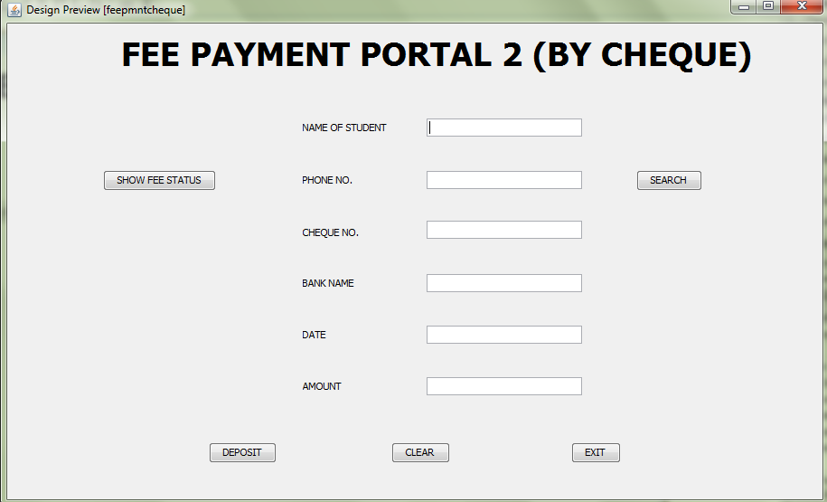

import java.sql.*;

import javax.swing.JOptionPane;

public class feepmntcheque extends javax.swing.JInternalFrame {

Connection con = null;

Statement stmt = null;

/** Creates new form feepmntcheque */

public feepmntcheque() {

initComponents();

try {

Class.forName("java.sql.DriverManager");

con = (Connection) DriverManager.getConnection("jdbc:mysql://localhost:3306/AADHAR","root","");

stmt = (Statement) con.createStatement();

} catch(Exception x)

{

JOptionPane.showMessageDialog(this, x.getMessage());

}

}

**ON CLICK OF SHOW FEE STATUS**

private void jButton1ActionPerformed(java.awt.event.ActionEvent evt) {

String Name,Phone,Cheque , BankName , Date , Amount;

Name = jTextField1.getText();

Phone = jTextField2.getText();

Cheque = jTextField3.getText();

BankName = jTextField4.getText();

Date = jTextField5.getText();

Amount = jTextField6.getText();

try{

Class.forName("java.sql.DriverManager");

Statement stmt = (Statement) con.createStatement();

String Query = "SELECT * FROM FEECH WHERE PHONE = '"+jTextField3.getText()+"';";

ResultSet rs = stmt.executeQuery(Query);

if(rs.next()) {

Name = rs.getString("Name");

Cheque = rs.getString("Cheque");

BankName = rs.getString("BankName");

Date = rs.getString("Date");

Amount = rs.getString("Amount");

jTextField1.setText(Name);

jTextField2.setText(Phone);

jTextField4.setText(BankName);

jTextField5.setText(Date);

jTextField6.setText(Amount);

} else {

JOptionPane.showMessageDialog(this, "SORRY! NO SUCH CHEQUE NUMBER EXISTS");

}

}catch(Exception e) {

JOptionPane.showMessageDialog(this,e.getMessage());

}

}

**ON CLICK OF SEARCH BUTTON**

private void jButton5ActionPerformed(java.awt.event.ActionEvent evt) {

String Name,Phone;

Name = jTextField1.getText();

Phone = jTextField2.getText();

try{

Class.forName("java.sql.DriverManager");

Statement stmt = (Statement) con.createStatement();

String Query = "SELECT * FROM NEWST WHERE PHONE = '"+jTextField2.getText()+"';";

ResultSet rs = stmt.executeQuery(Query);

if(rs.next()) {

Name = rs.getString("Name");

jTextField1.setText(Name);

} else {

JOptionPane.showMessageDialog(this, "SORRY! NO SUCH NUMBER EXISTS");

}

}catch(Exception e) {

JOptionPane.showMessageDialog(this,e.getMessage());

}

}

private void jButton1ActionPerformed(java.awt.event.ActionEvent evt) {

String Name,Phone,Cheque , BankName , Date , Amount;

Name = jTextField1.getText();

Phone = jTextField2.getText();

Cheque = jTextField3.getText();

BankName = jTextField4.getText();

Date = jTextField5.getText();

Amount = jTextField6.getText();

try{

Class.forName("java.sql.DriverManager");

Statement stmt = (Statement) con.createStatement();

String Query = "SELECT * FROM FEECH WHERE PHONE = '"+jTextField3.getText()+"';";

ResultSet rs = stmt.executeQuery(Query);

if(rs.next()) {

Name = rs.getString("Name");

Cheque = rs.getString("Cheque");

BankName = rs.getString("BankName");

Date = rs.getString("Date");

Amount = rs.getString("Amount");

jTextField1.setText(Name);

jTextField2.setText(Phone);

jTextField4.setText(BankName);

jTextField5.setText(Date);

jTextField6.setText(Amount);

} else {

JOptionPane.showMessageDialog(this, "SORRY! NO SUCH CHEQUE NUMBER EXISTS");

}

}catch(Exception e) {

JOptionPane.showMessageDialog(this,e.getMessage());

}

}

**ON CLICK OF DEPOSIT BUTTON**

private void jButton6ActionPerformed(java.awt.event.ActionEvent evt) {

String Name,Phone , Cheque , BankName , Date , Amount;

Name = jTextField1.getText();

Phone = jTextField2.getText();

Cheque = jTextField3.getText();

BankName = jTextField4.getText();

Date = jTextField5.getText();

Amount = jTextField6.getText();

try{

Class.forName("java.sql.DriverManager");

Statement stmt = (Statement) con.createStatement();

String Query = "INSERT INTO FEECH VALUES ( '"+jTextField1.getText()+"' ,'"+jTextField2.getText()+"','"+jTextField3.getText()+"','"+jTextField4.getText()+"','"+jTextField5.getText()+"','"+jTextField6.getText()+"');";

stmt = (Statement) con.createStatement();

stmt.executeUpdate(Query);

{

JOptionPane.showConfirmDialog(this, "ARE YOU SURE YOU WANT TO PAY ?");

{

JOptionPane.showMessageDialog(this, "YOUR CHEQUE HAS BEEN DEPOSITED SUCCESSFULLY!!!");

}

}

}catch(Exception e) {

JOptionPane.showMessageDialog(this,e.getMessage());

}

}

**ON CLICK OF CLEAR BUTTON**

jTextField1.setText("");

jTextField2.setText("");

jTextField3.setText("");

jTextField4.setText("");

jTextField5.setText("");

jTextField6.setText("");

**ON CLICK OF EXIT BUTTON**

private void jButton8ActionPerformed(java.awt.event.ActionEvent evt) {

this.dispose();

}

**Frame:newteacher.java**

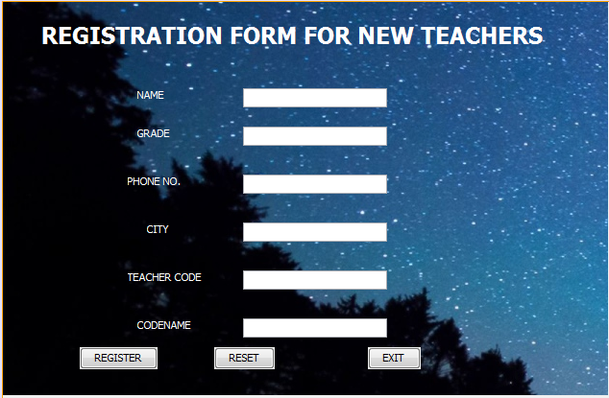

package aadhar;

import java.sql.*;

import javax.swing.JOptionPane;

public class newteacher extends javax.swing.JFrame {

Connection con = null;

Statement stmt = null;

/** Creates new form newteacher */

public newteacher() {

initComponents();

try {

Class.forName("java.sql.DriverManager");

con = (Connection) DriverManager.getConnection("jdbc:mysql://localhost:3306/AADHAR","root","");

stmt = (Statement) con.createStatement();

} catch(Exception x)

{

JOptionPane.showMessageDialog(this, x.getMessage());

}

}

**ON CLICK OF REGISTER BUTTON**

private void jButton1ActionPerformed(java.awt.event.ActionEvent evt) {

String NAME,GRADE,CITY,PHONE,CODE,CODENAME;

NAME = t1.getText();

GRADE = t2.getText();

CITY = t3.getText();

PHONE = t4.getText();

CODE = t5.getText();

CODENAME = cnt.getText();

try {

Class.forName("java.sql.DriverManager");

con = (Connection) DriverManager.getConnection("jdbc:mysql://localhost:3306/AADHAR","root","");

stmt = (Statement) con.createStatement();

String QUERY = "INSERT INTO TEACHERS VALUES('"+t1.getText()+"','"+t2.getText()+"','"+t3.getText()+"','"+t4.getText()+"','"+t5.getText()+"','"+cnt.getText()+"'););";

stmt.executeUpdate(QUERY);

{

JOptionPane.showMessageDialog(this, "REGISTERED !!!");

{

selectuser nf = new selectuser();

nf.setVisible(true);

}

}

} catch (Exception ef)

{

JOptionPane.showMessageDialog(this, ef.getMessage());

}

}

**ON CLICK OF RESET BUTTON**

private void jButton2ActionPerformed(java.awt.event.ActionEvent evt) {

t1.setText("");

t2.setText("");

t3.setText("");

t4.setText("");

t5.setText("");

cnt.setText("");

}

**ON CLICK OF EXIT BUTTON**

private void jButton3ActionPerformed(java.awt.event.ActionEvent evt) {

this.dispose();

}

**Frame: selectuser.java**

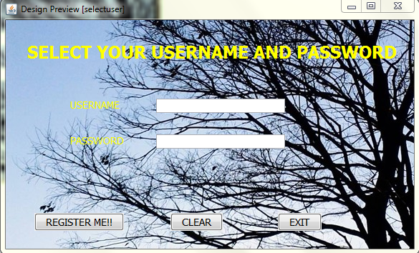

package aadhar;

import java.sql.*;

import javax.swing.JOptionPane;

public class selectuser extends javax.swing.JFrame {

Connection con = null;

Statement stmt = null;

/** Creates new form selectuser */

public selectuser() {

initComponents();

try {

Class.forName("java.sql.DriverManager");

con = (Connection) DriverManager.getConnection("jdbc:mysql://localhost:3306/AADHAR","root","");

stmt = (Statement) con.createStatement();

} catch(Exception x)

{

JOptionPane.showMessageDialog(this, x.getMessage());

}

}

**ON CLICK OF REGISTER ME!! BUTTON**

String U,P , QUERY = null;

U = tx1.getText();

P = new String(pf1.getPassword());

try {

Class.forName("java.sql.DriverManager");

con = (Connection) DriverManager.getConnection("jdbc:mysql://localhost:3306/AADHAR","root","");

stmt = (Statement) con.createStatement();

stmt.executeUpdate(QUERY);

QUERY = "INSERT INTO LOGIN VALUES('"+U+"','"+P+"');";

{

JOptionPane.showMessageDialog(this,"SUCCESSFULLY REGISTERD WELCOME !!!!!");

}

} catch (Exception ef) {

JOptionPane.showMessageDialog(this, ef.getMessage());

}

**ON CLICK OF CLEAR BUTTON**

private void jButton3ActionPerformed(java.awt.event.ActionEvent evt) {

tx1.setText("");

pf1.setText("");

}

**ON CLICK OF EXIT BUTTON**

private void jButton2ActionPerformed(java.awt.event.ActionEvent evt) {

this.dispose();

}

**Frame: STUDENTDET.java**

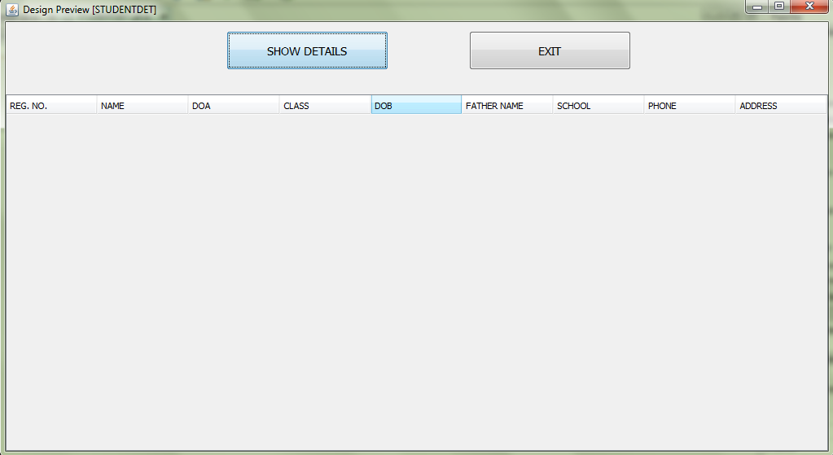

package aadhar;

import java.sql.*;

import javax.swing.JOptionPane;

import javax.swing.table.DefaultTableModel;

public class STUDENTDET extends javax.swing.JFrame {

Connection con;

Statement stmt,smt1;

ResultSet rs;

/** Creates new form STUDENTDET */

public STUDENTDET() {

initComponents();

try

{

Class.forName("com.mysql.jdbc.Driver");

con = DriverManager.getConnection("jdbc:mysql://localhost:3306/AADHAR","root","");

}

catch(Exception e)

{

JOptionPane.showMessageDialog(this, e.getMessage());

}

}

**ON CLICK OF SHOW DETAILS BUTTON**

private void jButton1ActionPerformed(java.awt.event.ActionEvent evt) {

String NAME;

String CLASS;

String FATHERS_NAME;

String SCHOOL;

String ADDRESS;

String REGNO;

Date DOA;

Date DOB;

String PHONE;

{

DefaultTableModel model = (DefaultTableModel) jTable1.getModel();

try{

stmt = con.createStatement();

String Query;

Query = "SELECT * FROM NEWST;";

rs = stmt.executeQuery(Query);

while(rs.next())

{

REGNO = rs.getString("REGNO");

NAME = rs.getString("NAME");

DOA = rs.getDate("DOA");

CLASS = rs.getString("CLASS");

DOB = rs.getDate("DOB");

FATHERS_NAME = rs.getString("FATHERS_NAME");

SCHOOL = rs.getString("SCHOOL");

PHONE = rs.getString("PHONE");

ADDRESS = rs.getString("ADDRESS");

model.addRow(new Object[] {REGNO,NAME,DOA,CLASS,DOB,FATHERS_NAME,SCHOOL,PHONE,ADDRESS});

}

}catch(Exception e)

{

JOptionPane.showMessageDialog(this, e.getMessage());

}

}

}

**ON CLICK OF EXIT BUTTON**

private void jButton2ActionPerformed(java.awt.event.ActionEvent evt) {

this.dispose();

}

**Frame: TEACHERDET.java**

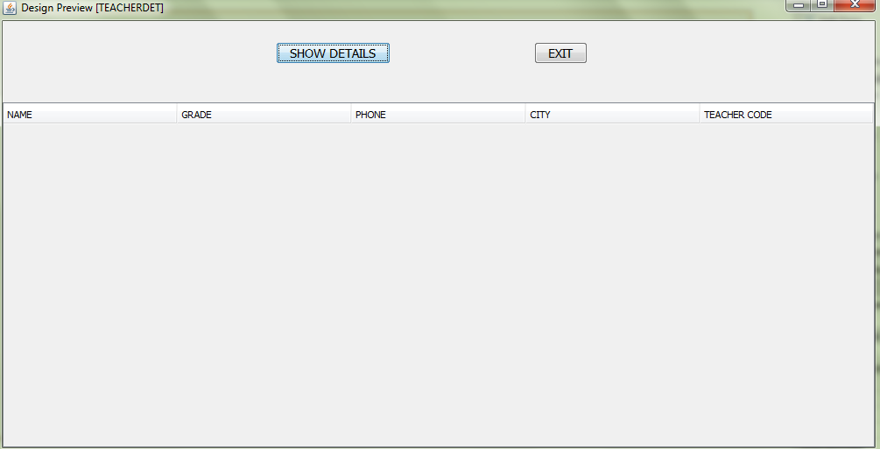

package aadhar;

import java.sql.*;

import javax.swing.JOptionPane;

import javax.swing.table.DefaultTableModel;

public class TEACHERDET extends javax.swing.JFrame {

Connection con;

Statement stmt,smt1;

ResultSet rs;

/** Creates new form TEACHERDET */

public TEACHERDET() {

initComponents();

try

{

Class.forName("com.mysql.jdbc.Driver");

con = DriverManager.getConnection("jdbc:mysql://localhost:3306/AADHAR","root","");

}

catch(Exception e)

{

JOptionPane.showMessageDialog(this, e.getMessage());

}

}

**ON CLICK OF SHOW DETAILS BUTTON**

private void jButton1ActionPerformed(java.awt.event.ActionEvent evt) {

String NAME;

String GRADE;

String PHONE;

String CITY;

String TEACHER_CODE;

{

DefaultTableModel model = (DefaultTableModel) jTable1.getModel();

try{

stmt = con.createStatement();

String Query;

Query = "SELECT * FROM TEACHERS;";

rs = stmt.executeQuery(Query);

while(rs.next())

{

NAME = rs.getString("NAME");

GRADE = rs.getString("GRADE");

PHONE = rs.getString("PHONE");

CITY = rs.getString("CITY");

TEACHER_CODE = rs.getString("TEACHER_CODE");

model.addRow(new Object[] {NAME,GRADE,PHONE,CITY,TEACHER_CODE});

}

}catch(Exception e)

{

JOptionPane.showMessageDialog(this, e.getMessage());

}

}

}

**ON CLICK OF EXIT BUTTON**

private void jButton2ActionPerformed(java.awt.event.ActionEvent evt) {

this.dispose();

}

**Frame: resetpass.java**

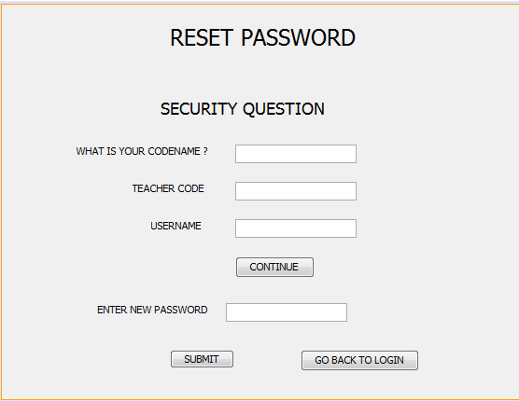

package aadhar;

import java.sql.*;

import javax.swing.JOptionPane;

public class resetpass extends javax.swing.JFrame {

Connection con = null;

Statement stmt = null;

public resetpass() {

initComponents();

jLabel5.setVisible(false);

pr1.setVisible(false);

jButton2.setVisible(false);

jButton3.setVisible(false);

try {

Class.forName("java.sql.DriverManager");

con = (Connection) DriverManager.getConnection("jdbc:mysql://localhost:3306/AADHAR","root","");

stmt = (Statement) con.createStatement();

} catch(Exception x)

{

JOptionPane.showMessageDialog(this, x.getMessage());

}

}

**ON CLICK OF CONTINUE BUTTON**

private void jButton1ActionPerformed(java.awt.event.ActionEvent evt) {

String CODENAME ,C = null , TEACHER_CODE;

CODENAME = tr1.getText();

TEACHER_CODE = tr2.getText();

String TC = null;

try{ String Query = "SELECT CODENAME FROM TEACHERS WHERE TEACHER_CODE = '"+tr2.getText()+"';";

ResultSet rs = stmt.executeQuery(Query);

if(rs.next())

{

TC = rs.getString("TEACHER_CODE");

C = rs.getString("CODENAME");

}

else

{

JOptionPane.showMessageDialog(this, "SORRY! NO TEACHER FOUND FOR THIS CODE");

}

}catch(Exception S)

{

JOptionPane.showMessageDialog(this,S.getMessage());

}

if(C.equals(CODENAME))

{ jLabel5.setVisible(true);

pr1.setVisible(true);

jButton2.setVisible(true);

jButton3.setVisible(true);

}

else

{

JOptionPane.showMessageDialog(this, "SORRY BUT YOU ARE NOT REGISTERED!!!!!!");

}

}

**ON CLICK OF SUBMIT BUTTON**

private void jButton2ActionPerformed(java.awt.event.ActionEvent evt) {

String USERNAME , PASSWORD;

PASSWORD = new String(pr1.getPassword());

USERNAME = ut.getText();

try{ String Query = "UPDATE LOGIN SET PASSWORD = '"+PASSWORD+"' WHERE ID = '"+USERNAME+"';";

int stmt1 = stmt.executeUpdate(Query);

{

JOptionPane.showMessageDialog(this, "PASSWORD RESET SUCCESSFULL !!!");

{

jButton3.setVisible(true);

}

}

}catch(Exception e)

{

JOptionPane.showMessageDialog(this,e.getMessage());

}

}

**ON CLICK OF GO BACK TO LOGIN BUTTON**

private void jButton3ActionPerformed(java.awt.event.ActionEvent evt) {

loginpage nf = new loginpage();

nf.setVisible(true);

{

this.dispose();

}

}

**Frame: MATDOWPHY.java**

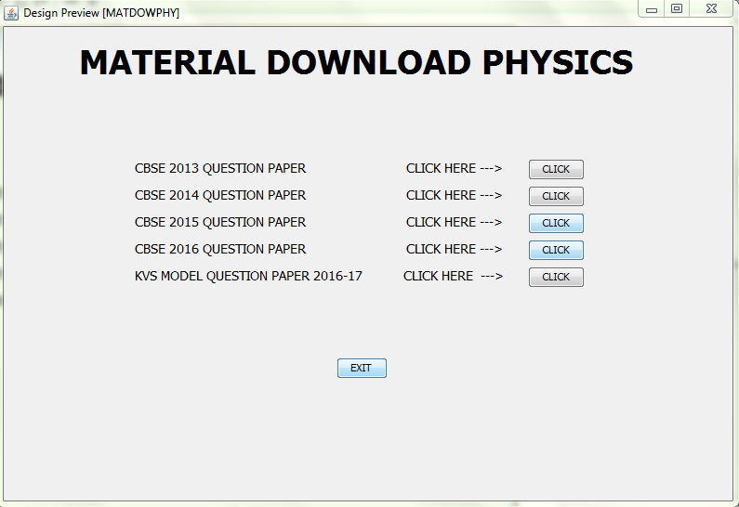

package aadhar;

import java.awt.Desktop;

import java.io.File;

import javax.swing.JOptionPane;

**ON CLICK OF ALL CLICK BUTTONS**

private void jButton1ActionPerformed(java.awt.event.ActionEvent evt) {

try{

File f = new File("C:\\Users\\kv\\Documents\\NetBeansProjects\\AADHAReP\\New folder\\XII Model Q P PHYSICS.pdf");

Desktop.getDesktop().open(f);

}catch(Exception e)

{

JOptionPane.showMessageDialog(this, e.getMessage());

}

}

private void jButton3ActionPerformed(java.awt.event.ActionEvent evt) {

try{

File H = new File("C:\\Users\\kv\\Documents\\NetBeansProjects\\AADHAReP\\New folder\\CBSE-Class-12th-Physics-2013.pdf");

Desktop.getDesktop().open(H);

}catch(Exception W)

{

JOptionPane.showMessageDialog(this, W.getMessage());

}

}

private void jButton4ActionPerformed(java.awt.event.ActionEvent evt) {

try{

File S = new File("C:\\Users\\kv\\Documents\\NetBeansProjects\\AADHAReP\\New folder\\cbse-physics-2014-12-paper-1.pdf");

Desktop.getDesktop().open(S);

}catch(Exception A)

{

JOptionPane.showMessageDialog(this, A.getMessage());

}

}

private void jButton5ActionPerformed(java.awt.event.ActionEvent evt) {

try{

File d = new File("C:\\Users\\kv\\Documents\\NetBeansProjects\\AADHAReP\\New folder\\CBSE-2015-PHYSICS-CLASS-12-SET-3.pdf");

Desktop.getDesktop().open(d);

}catch(Exception b)

{

JOptionPane.showMessageDialog(this, b.getMessage());

}

}

private void jButton6ActionPerformed(java.awt.event.ActionEvent evt) {

try{

File k = new File("C:\\Users\\kv\\Documents\\NetBeansProjects\\AADHAReP\\New folder\\cbse-2016-physics-class-12-set-2.pdf");

Desktop.getDesktop().open(k);

}catch(Exception l)

{

JOptionPane.showMessageDialog(this, l.getMessage());

}

}

**ON CLICK OF EXIT BUTTON**

private void jButton7ActionPerformed(java.awt.event.ActionEvent evt) {

JOptionPane.showMessageDialog(this, "BYE BYE :-)");

{

this.dispose();

}

}

**Frame: MATDOWCHEM.java**

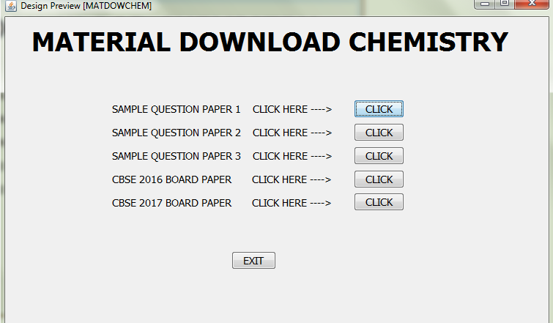

package aadhar;

import java.awt.Desktop;

import java.io.File;

import javax.swing.JOptionPane;

**ON CLICK OF ALL CLICK BUTTONS**

private void jButton6ActionPerformed(java.awt.event.ActionEvent evt) {

try{

File f = new File("C:\\Users\\kv\\Documents\\NetBeansProjects\\AADHAReP\\New folder\\CBSE-CBSE-Class-12-Board-Exam-2017-Chemistry-Question-Paper.pdf");

Desktop.getDesktop().open(f);

}catch(Exception e)

{

JOptionPane.showMessageDialog(this, e.getMessage());

}

}

private void jButton1ActionPerformed(java.awt.event.ActionEvent evt) {

try{

File f = new File("C:\\Users\\kv\\Documents\\NetBeansProjects\\AADHAReP\\New folder\\CHEM_XII_PRE_B_QP__2016-17_01.docx");

Desktop.getDesktop().open(f);

}catch(Exception e)

{

JOptionPane.showMessageDialog(this, e.getMessage());

}

}

private void jButton3ActionPerformed(java.awt.event.ActionEvent evt) {

try{

File f = new File("C:\\Users\\kv\\Documents\\NetBeansProjects\\AADHAReP\\New folder\\Q.P XII .docx");

Desktop.getDesktop().open(f);

}catch(Exception e)

{

JOptionPane.showMessageDialog(this, e.getMessage());

}

}

private void jButton4ActionPerformed(java.awt.event.ActionEvent evt) {

try{

File f = new File("C:\\Users\\kv\\Documents\\NetBeansProjects\\AADHAReP\\New folder\\CHEM XII QP PRE BOARD 2016-17.doc");

Desktop.getDesktop().open(f);

}catch(Exception e)

{

JOptionPane.showMessageDialog(this, e.getMessage());

}

}

private void jButton5ActionPerformed(java.awt.event.ActionEvent evt) {

try{

File f = new File("C:\\Users\\kv\\Documents\\NetBeansProjects\\AADHAReP\\New folder\\cbse-2016-chemistry-class-12-set-1.pdf");

Desktop.getDesktop().open(f);

}catch(Exception e)

{

JOptionPane.showMessageDialog(this, e.getMessage());

}

}

**ON CLICK OF EXIT BUTTON**

private void jButton7ActionPerformed(java.awt.event.ActionEvent evt) {

JOptionPane.showMessageDialog(this, "BYE BYE :-)");

{

this.dispose();

}

}

**Frame: MATDOWCHEM.java**

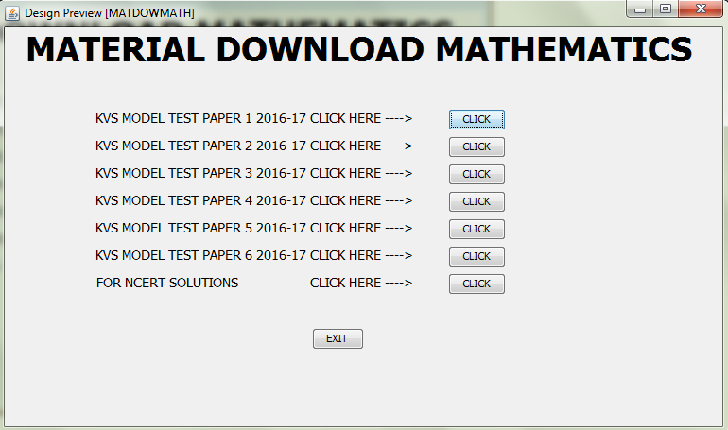

package aadhar;

import java.awt.Desktop;

import java.io.File;

import javax.swing.JOptionPane;

**ON CLICK OF ALL CLICK BUTTONS**

private void jButton1ActionPerformed(java.awt.event.ActionEvent evt) {

try{

File f = new File("C:\\Users\\kv\\Documents\\NetBeansProjects\\AADHAReP\\Maths\\Model Test Paper-I.pdf");

Desktop.getDesktop().open(f);

}catch(Exception e)

{

JOptionPane.showMessageDialog(this, e.getMessage());

}

}

private void jButton2ActionPerformed(java.awt.event.ActionEvent evt) {

try{

File f = new File("C:\\Users\\kv\\Documents\\NetBeansProjects\\AADHAReP\\Maths\\Model Test Paper-II.pdf");

Desktop.getDesktop().open(f);

}catch(Exception e)

{

JOptionPane.showMessageDialog(this, e.getMessage());

}

}

private void jButton3ActionPerformed(java.awt.event.ActionEvent evt) {

try{

File f = new File("C:\\Users\\kv\\Documents\\NetBeansProjects\\AADHAReP\\Maths\\Model Test Paper-III.pdf");

Desktop.getDesktop().open(f);

}catch(Exception e)

{

JOptionPane.showMessageDialog(this, e.getMessage());

}

}

private void jButton4ActionPerformed(java.awt.event.ActionEvent evt) {

try{

File f = new File("C:\\Users\\kv\\Documents\\NetBeansProjects\\AADHAReP\\Maths\\Model Test Paper-IV.pdf");

Desktop.getDesktop().open(f);

}catch(Exception e)

{

JOptionPane.showMessageDialog(this, e.getMessage());

}

}

private void jButton5ActionPerformed(java.awt.event.ActionEvent evt) {

try{

File f = new File("C:\\Users\\kv\\Documents\\NetBeansProjects\\AADHAReP\\Maths\\Model Test Paper-V.pdf");

Desktop.getDesktop().open(f);

}catch(Exception e)

{

JOptionPane.showMessageDialog(this, e.getMessage());

}

}

private void jButton6ActionPerformed(java.awt.event.ActionEvent evt) {

try{

File f = new File("C:\\Users\\kv\\Documents\\NetBeansProjects\\AADHAReP\\Maths\\Model Test Paper-VI.pdf");

Desktop.getDesktop().open(f);

}catch(Exception e)

{

JOptionPane.showMessageDialog(this, e.getMessage());

}

}

private void jButton8ActionPerformed(java.awt.event.ActionEvent evt) {

try{

File f = new File("C:\\Users\\kv\\Documents\\NetBeansProjects\\AADHAReP\\Ncert Solution");

Desktop.getDesktop().open(f);

}catch(Exception e)

{

JOptionPane.showMessageDialog(this, e.getMessage());

}

}

**ON CLICK OF EXIT BUTTON**

private void jButton7ActionPerformed(java.awt.event.ActionEvent evt) {

JOptionPane.showMessageDialog(this, "BYE BYE :-)");

{

this.dispose();

}

}

**User Manual**

## How to Install Software:

### Hardware Requirement-

* Intel Pentium/Celeron or similar processor based PC at Client/Server end.
* 128 MB RAM and 4GB HDD space (for Database) is desirable.
* Standard I/O devices like Keyboard and Mouse etc.
* Local Area Network(LAN) is required for Client-Server Installation

### Software Requirement-

* Windows XP/2007 OS is desirable.
* NetBeans Ver 6.5.1 or higher should be installed with JDK and JVM.
* MySQL Ver 6.1 with Library Database must be present at machine.

### Database Installation

Firstly you have to execute the file aadhar.txt provided in the project folder. It has queries written on it you have to just copy them and paste it to your sql screen. This will create a database named Aadhar along with its 5 tables.

**References**

In order to work on this project titled –***Aadhar Tutorials,*** the following books and literature are refered by me during the various phases of development of the project.

1. <http://www.mysql.org/>
2. <http://www.netbeans.org>/

3. On-line Help of NetBeans ®

4. Informatics Practices for class XII

-by Sumita Arora

5. Together with Informatics Practices

6. Various Websites of Discussion Forum and software development activities.

Other than the above-mentioned books, the suggestions and supervision of my teacher and my class experience also helped me to develop this software project. My father also provided his valuable suggestions so as to complete the project on time.